**Housing Prices in Lisbon**

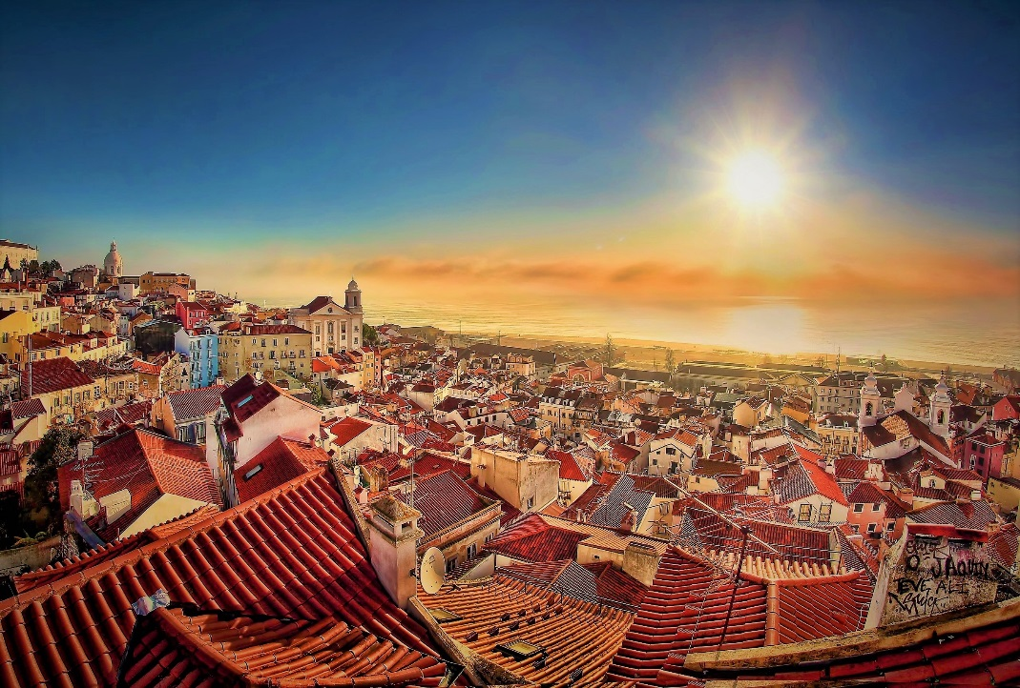Realized by João Santos

**Introduction**

Lisbon is the stunning capital city of Portugal and is one of the most charismatic and vibrant cities of Europe. It is a city that effortlessly blends traditional heritage, with striking modernism and progressive thinking. As a holiday destination, Lisbon offers a rich and varied history, a buzzing nightlife and is blessed with a glorious year-round climate. Data shows over 4,5 Million tourists visit Lisbon, per year, being Lisbon one of the most desired places to visit. The district is divided into 16 municipals in total, and each of them have different aspects that makes them unique. As a resident of this city, I decided to use Lisbon as my project. With this project, investors, young people looking for houses, can find the most affordable regions to live on, as well some information regarding venues.

If we think of the city residents, they may want to choose the regions where real estate values are lower, too. At the same time, they may want to choose the district according to the social place’s density. However, it is difficult to obtain information that will guide investors in this direction, nowadays. When we consider all these problems, we can create a map and information chart where the real estate index is placed on Lisbon and each municipal is clustered according to the venue density.

**Data Description**

In this project, I got data from two sources: Second-level Administrative Divisions of Portugal from Spatial Data Repository of NYU and Price per square meter in Portugal municipals. From the first one, the .json file has coordinates of the all city of Portugal. I cleaned the data and reduced it to city of Lisbon where I used it to create choropleth map of the prices per square meter in the district of Lisbon. The second is a dataset that contained the price per square meter in all municipals in Portugal. Also, I used Foursquare API to get the most common venues of given Borough of Lisbon, alongside Google Map, ‘Search Nearby’ option to get the center coordinates of each Borough.

**Methodology**

As a database, I used GitHub repository in my study. I used python folium library to visualize geographic details of Lisbon and its counties, furthermore I used the Foursquare API to explore the boroughs and segment them. I designed the limit as 100 venue and the radius 750 meter for each borough from their given latitude and longitude information’s.

**Procedure**

Through the data available from *Jornal de Negócios* [1] , I was able to represent the list of municipals of Lisbon, with the associated price per square meter. After it, the goal was to get the geo-location of each of municipals, and so geolocator was used in order to get this information. **(Annex.1)**

Next, from the Forsquare API, the objective was to get the venues categories, and then rearrange the different municipals by common venues in each borough. With further manipulation of data, for each Municipal, we’ll get the descendent order, by common venues in each section. **(Annex.2)**

We have some common venue categories in boroughs. In this reason I used unsupervised learning **K-means algorithm** to cluster the boroughs. K-Means algorithm is one of the most common cluster method of unsupervised learning. I decided to run K-Means to cluster the boroughs into **5** clusters because when I analyze the different areas and regions, I found it important and clear that 5 group of venues would matter to a more detailed individual that is seeking certain features in Lisbon. From the data observed, I decided to characterize each one of the clusters by:

|  |  |  |
| --- | --- | --- |
| Cluster | Description | Color |
| 1 | Café and Bar Venues | Purple |
| 2 | Restaurant & Sport Venues | Red |
| 3 | Store Venues | Blue |
| 4 | Local Restaurants Venues | Orange |
| 5 | Golf & Social Venues | Green |

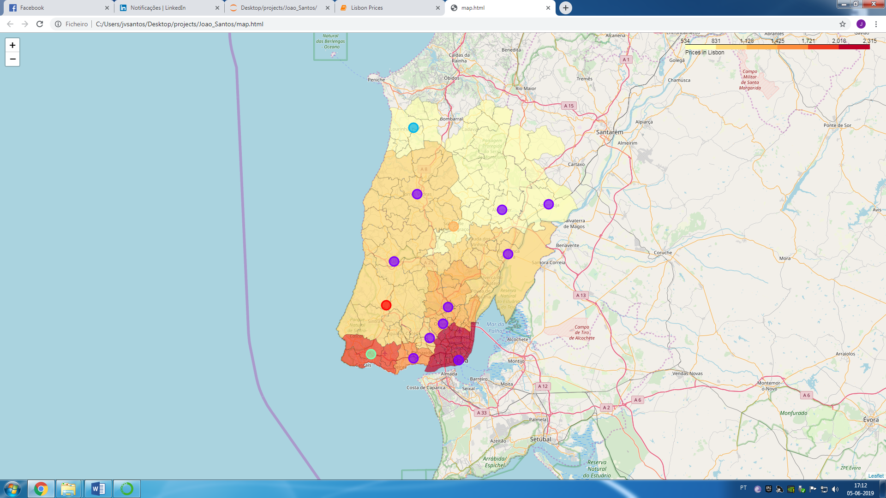Finally, applying the folium library, the visual representation of the choropleth map of the prices per square meter in the district of Lisbon is:

**Results**

From the data collected and the visualization, the main results are that the most expensive regions are associated with the ones that are close with Great Lisbon and close to the nearest maritime areas. Areas such as, Cascais, Oeiras, Great Lisbon, Loures are the areas that have the highest values in terms of price per square meter that correspond with a value higher than 1.228€. In contrast, we have Cadaval, Lourinhã, Alenquer and Azambuja with the lowest values of our study with values below 831€. These results are expected because it is in the centre of Lisbon that the demand for these spaces is more accentuated, therefore it’s reasonable to conclude that our analysis falls exactly on what reality reflects.

**Conclusion**

In conclusion, with this work, individuals can now make more informative decisions, regarding the spaces and the cost associated with it in Lisbon. Furthermore, it is possible to compare these spaces with the most common venues that satisfy the customer’s requirements. For example, taking into consideration only the economic point of view of the price of square meter, if a customer aims to live near Great Lisbon, paying the least for square meter, this study would indicate Amadora as the best choice, since it is located near Great Lisbon, and has the lowest value of price per square meter. From the visualization above, one may choose his favorite space in Lisbon to open a shop or startup, according to the preferences in terms of venues. When opening a store, if the objective is purely having contact with customers, the best choices will be: Great Lisbon and Cascais, due to the agglomerate of people, but also due to being characterized by being a social sphere. On the other hand, if the objective of the store is merely, to have a physical location of the startup, for example, then a lower cost per square meter, would be the best choice, meaning, Lourinhã, Cadaval, Alenquer and Azambuja being the best spots to do so.

**Annex**

**Annex.1 –** Each Municipal with square meter prices and geo-location.

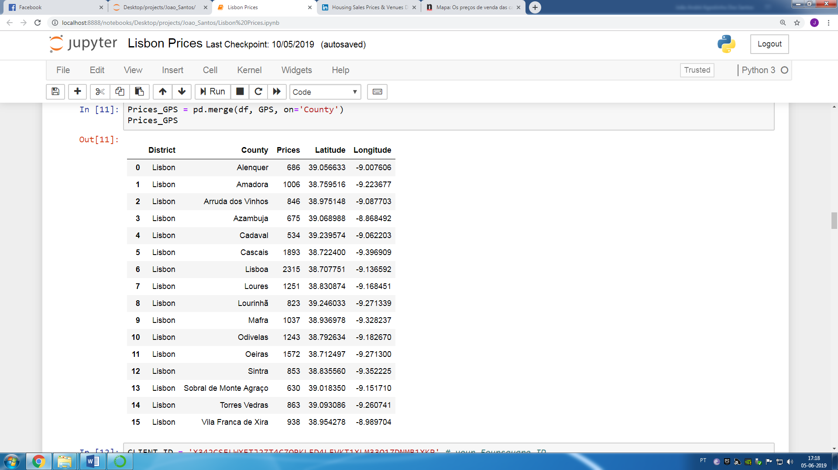

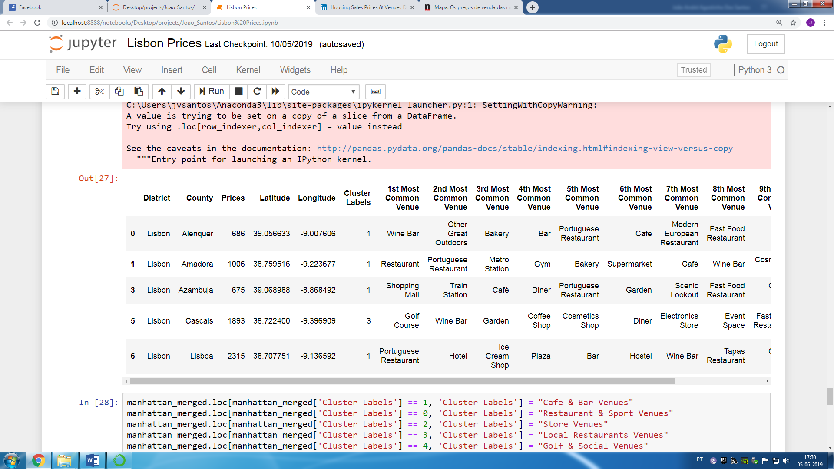**Annex.2 –** 5 first municipals with cluster labels and the correspondent most commons venues.

1. https://www.jornaldenegocios.pt/empresas/imobiliario/detalhe/mapa-os-precos-das-casas-em-todos-os-concelhos-de-130-euros-em-pampilhosa-a-2753-euros-em-lisboa